JAVA ASSIGNMENT 5

NAME: Hemakshi Bhatnagar

PRN: 21070126036

BATCH: A2

PART 1:  Implement the generic Shapes class as an interface s so that we can implement concrete classes like circle, triangle, rectangle class from it.

**Interface shape:**

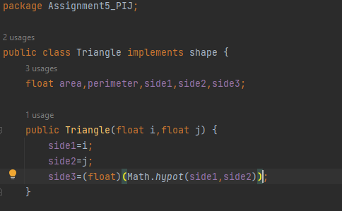

**CLASS Circle:**

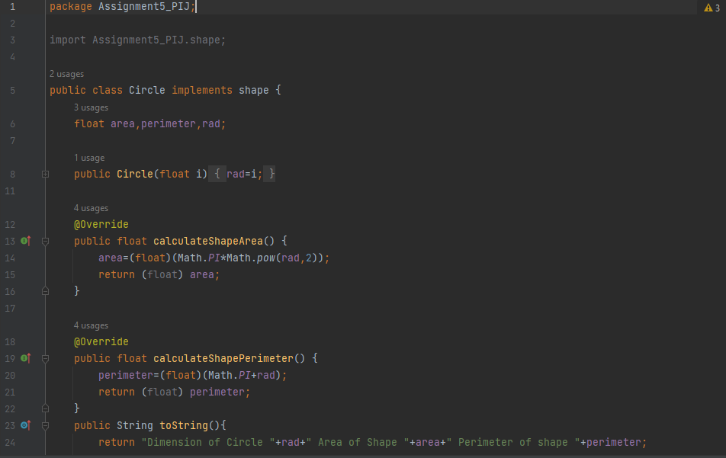

**CLASS Rectangle:**

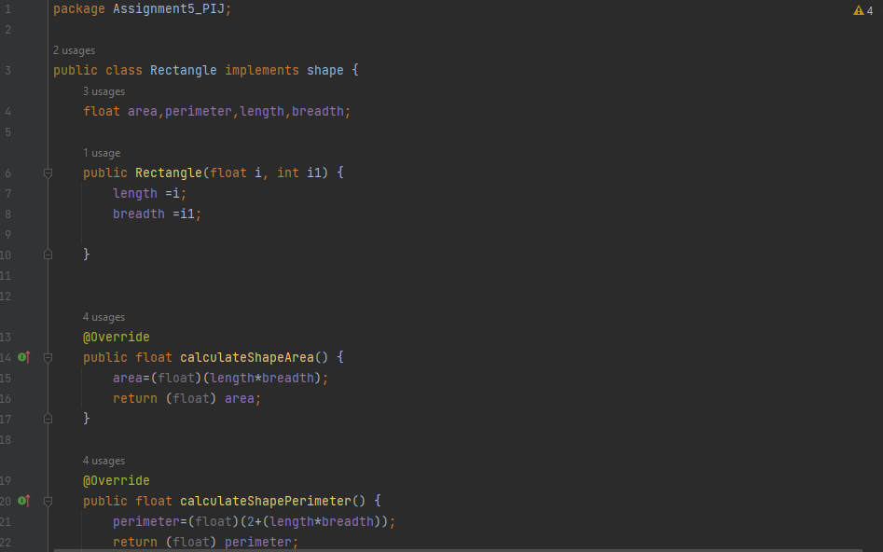

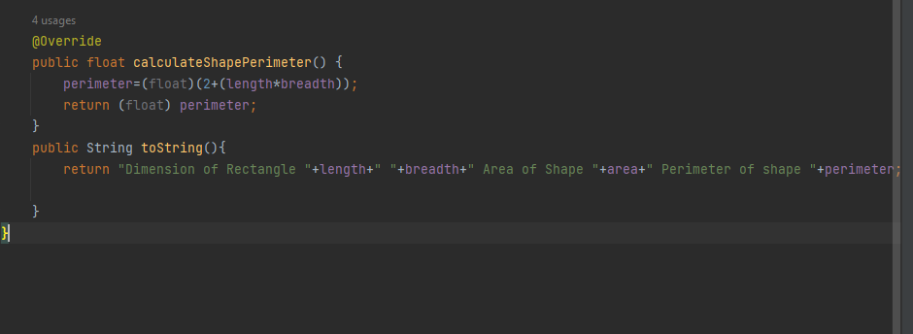

**CLASS Square:**

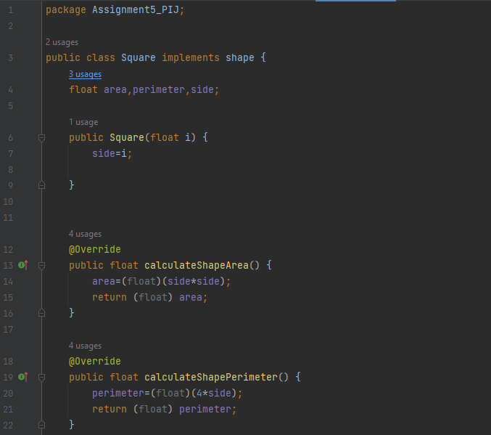

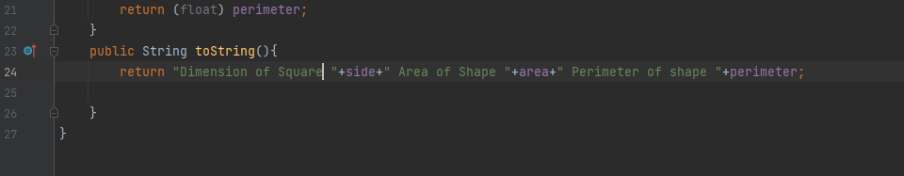

**CLASS Triangle:**

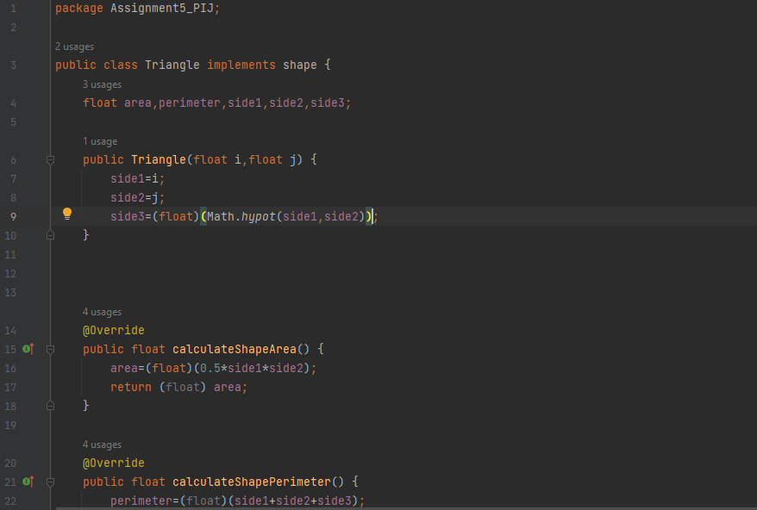

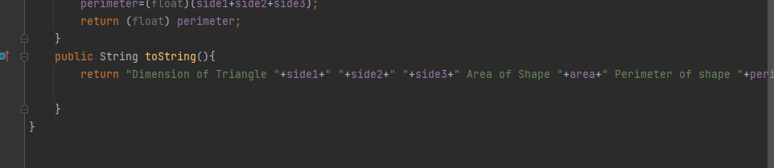

**CLASS Main:**

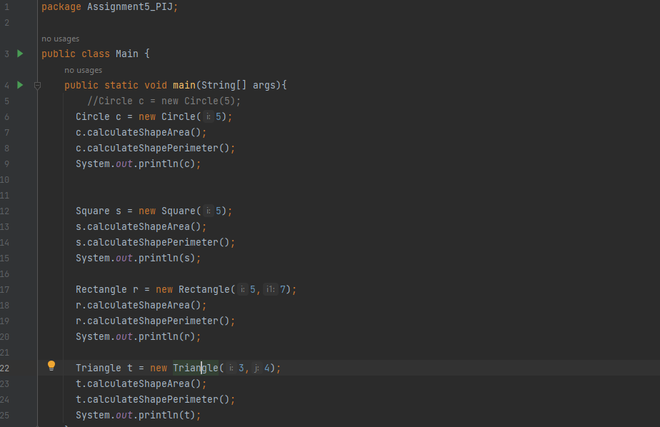

**OUTPUT:**

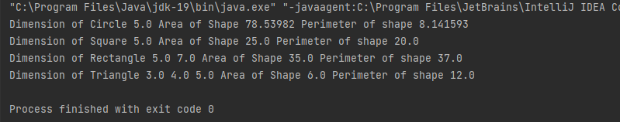

PART 2: Refer the excel sheet for salary calculation.   
In this exercise, take an  
abstract class which is defined below and develop two classes. The abstract  
class represents the basic building block for employees in a personnel  
database

**CLASS Employee:**

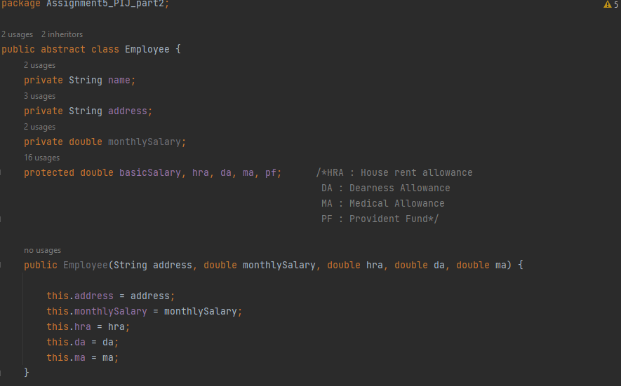

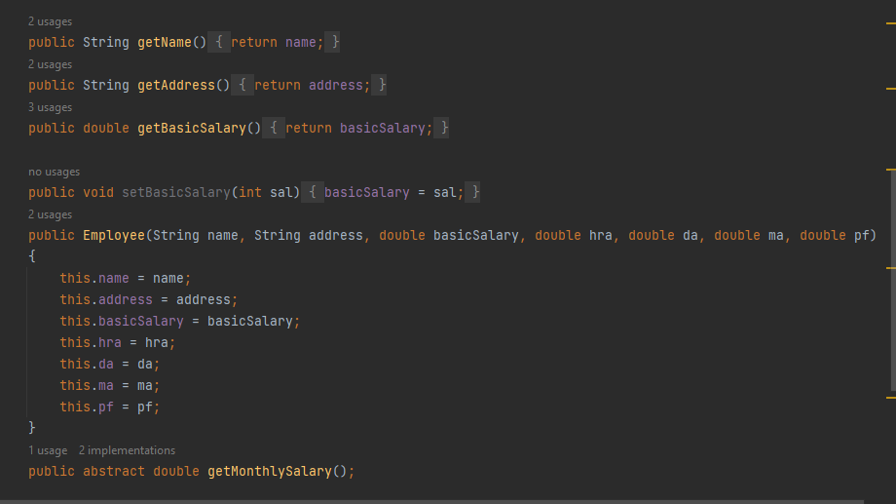

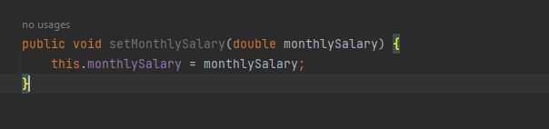

**CLASS EmployeeBonus:**

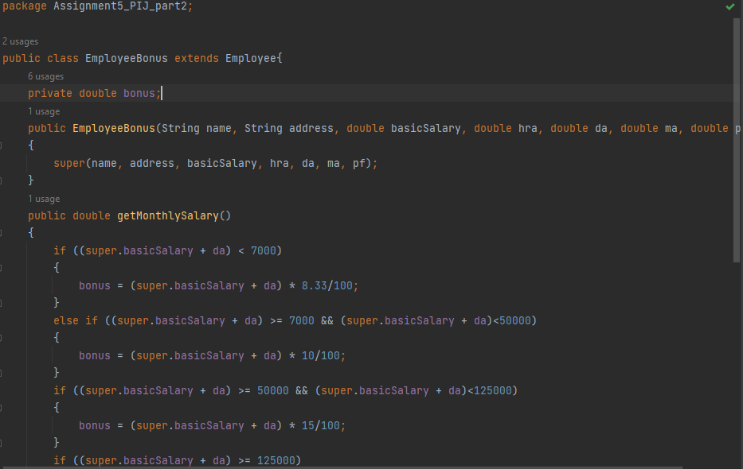

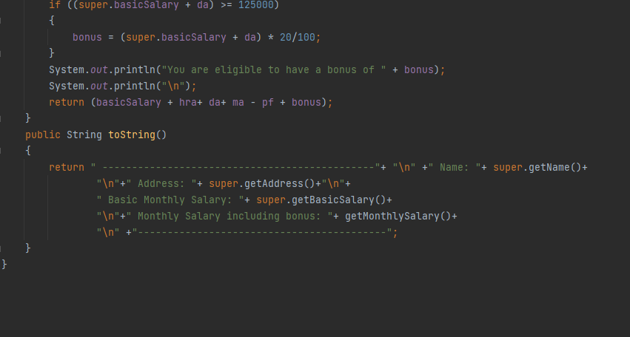

**CLASS NormalEmployee:**

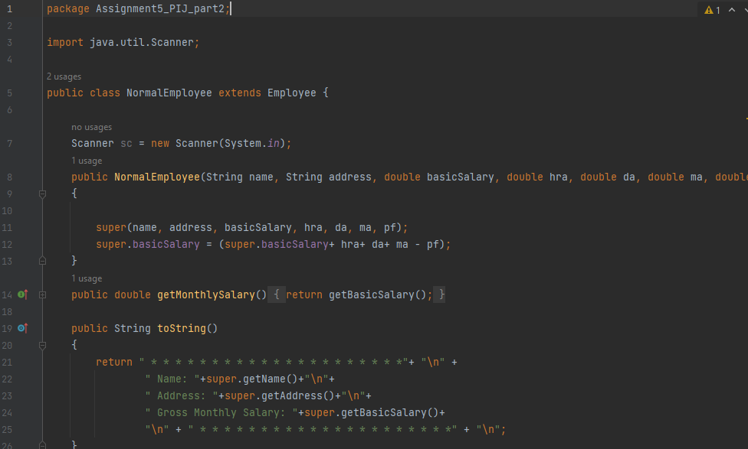

**CLASS MainEmployee:**

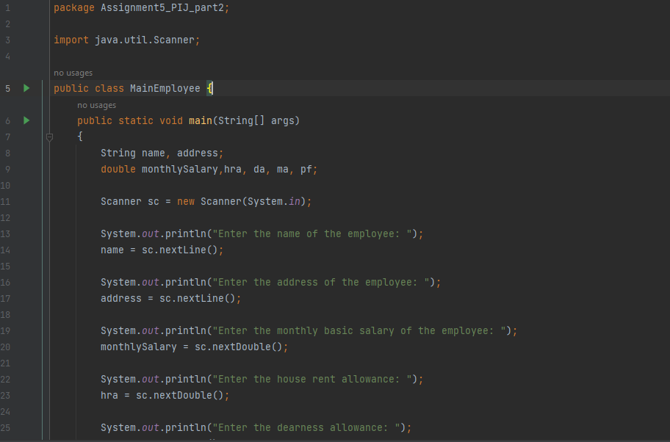

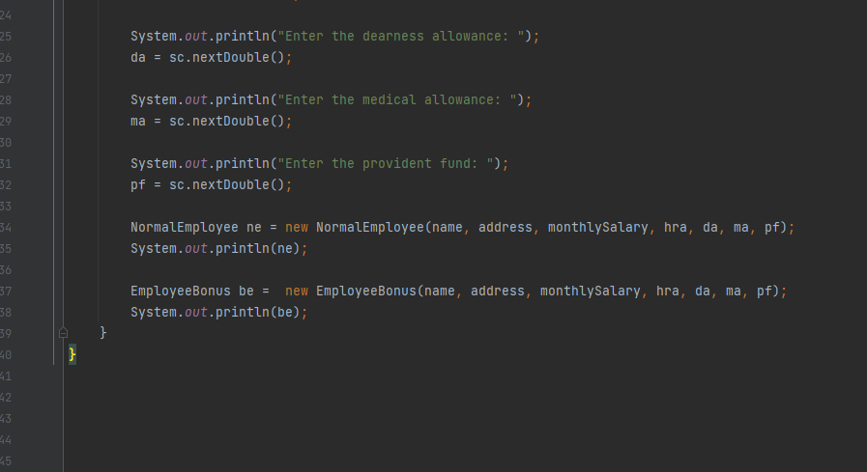

**OUTPUT:**

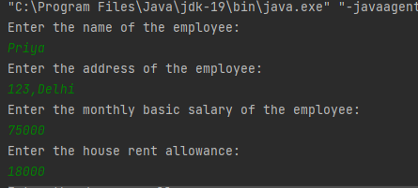

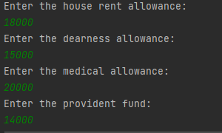

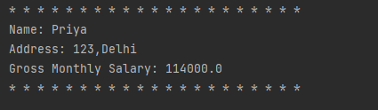

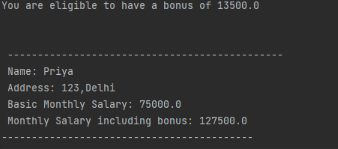

<https://github.com/Hemakshi011/Java_Assignment5>